“According to the European Commission's latest statistics, the EU-wide youth joblessness rate stands at 23.5 percent. A total of 7.5 million aged 15 - 24 year olds are neither in work, education or training.”

If you had a policymaking magic wand, how could/would you help to reduce high rates of natural unemployment (not just youth) in the E.U.? Identify at least 3 solutions.
Be prepared to cite the article, share your ideas, discuss the problems of implementing your solutions and question the solutions prepared by others.

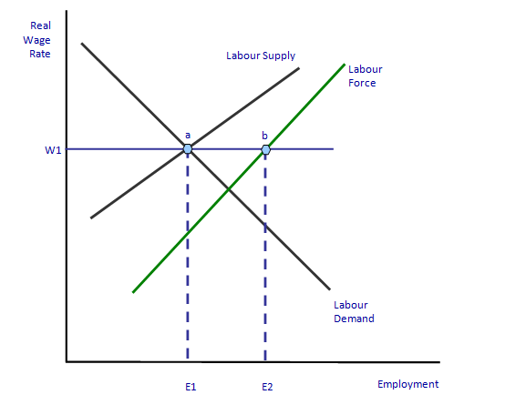
In the graph above, natural unemployment (e1 – e2) exists at a wage rate of w1. Your solutions should focus mostly on reducing frictional and structural unemployment.

