Marginality Utility
Utility = satisfaction/benefit

Marginal Utility = the additional satisfaction gained from consuming another unit of a good/service.

Total Utility = the total satisfaction from consuming a given number of goods.

Using the music model on the board, answer the following:
- At what point would someone likely stop listening to the new song? Why?
- If this person derived 5 units of satisfaction from listening to another song that they like, at what point would they stop listening to the first song, in favor of this one?

Q: Water is much more essential than diamonds but people are willing to pay more for diamonds – why?

A:
First, diamonds are much more scarce than water is. Due to clever marketing, demand for quality diamonds is high while supply is limited. In the average lifespan, the average person consumes only one or a few diamonds. The marginal utility of these diamonds is quite high, though the total utility is quite low compared to water.
Water is essential, and in our society it is relatively plentiful. The average family of four uses 400 gallons every day. So, although each additional gallon you use doesn’t bring that much more satisfaction (low marginal utility at high levels of consumption), throughout a year or decade your total utility for water is very high.

Q: If something has a very high marginal utility, does that mean it will be very valuable?
A: The theory of marginal utility, which is based on the subjective theory of value, says that the price at which an object trades in the market is determined neither by how much labor was exerted in its production, as in the labor theory of value, nor on how useful it is on a whole (total utility). Rather, its price is determined by its marginal utility. The marginal utility of a good is derived from its most important use to a person. So, if someone possesses a good, he will use it to satisfy some need or want. Which one? Naturally, the one that takes highest-priority. Eugen von Bohm-Bawerk illustrated this with the example of a farmer having five sacks of grain.
With the first, he will make bread to survive. With the second, he will make more bread, in order to be strong enough to work. With the next, he will feed his farm animals. The next is used to make whisky, and the last one he feeds to the pigeons. If one of those bags is stolen, he will not reduce each of those activities by one-fifth; instead he will stop feeding the pigeons.
So the value of the fifth bag of grain is equal to the satisfaction he gets from feeding the pigeons. If he sells that bag and neglects the pigeons, his least productive use of the remaining grain is to make whisky, so the value of a fourth bag of grain is the value of his whisky. Only if he loses four bags of grain will he start eating less; that is the most productive use of his grain. The last bag of grain is worth his life.
In explaining the diamond-water paradox, marginalists explain that it is not the total usefulness of diamonds or water that matters, but the usefulness of each unit of water or diamonds. It is true that the total utility of water to people is tremendous, because they need it to survive. However, since water is in such large supply in the world, the marginal utility of water is low. In other words, each additional unit of water that becomes available can be applied to less urgent uses as more urgent uses for water are satisfied.
Therefore, any particular unit of water becomes worth less to people as the supply of water increases. On the other hand, diamonds are in much lower supply. They are of such low supply that the usefulness of one diamond is greater than the usefulness of one glass of water, which is in abundant supply. Thus, diamonds are worth more to people. Therefore, those who want diamonds are willing to pay a higher price for one diamond than for one glass of water, and sellers of diamonds ask a price for one diamond that is higher than for one glass of water.
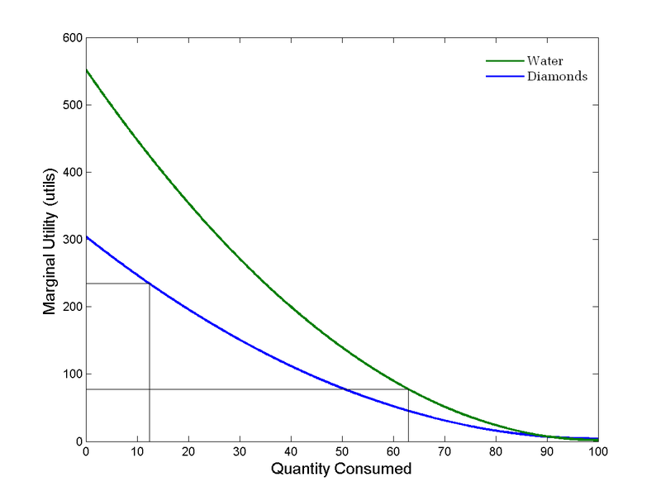
Diminishing Marginal Utility: At very low levels of consumption, water has a much higher marginal utility than diamonds. Marginal utility diminishes as quantity increases.

